SDG - BASED ASSIGNMENT
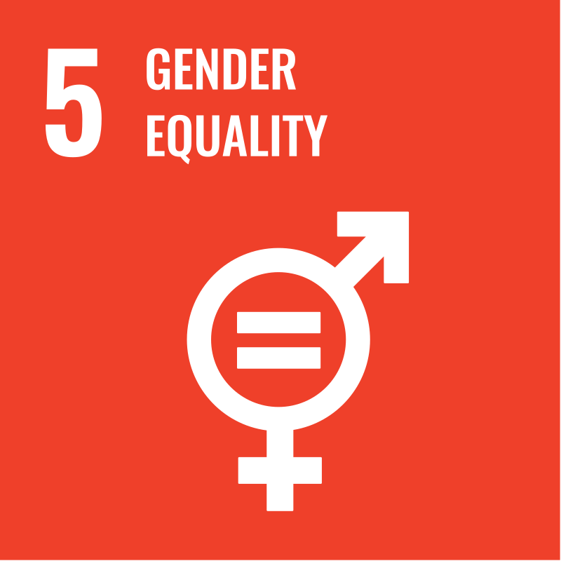


PRESENTED BY  Nabira Khan 23K-0914  SDG CHOSEN  SDG 5 - Gender Equality  COUNTRY/REGION  Scotland | SUBMITTED TO  Dr. Wajiha Raheeq  Lecturer, Civics and Community Engagement  SUBMISSION DATE  May 1st, 2025

INTRODUCTION
Sustainable Development Goal 5 (SDG 5) aims to achieve gender equality and empower all women and girls. This goal is integral to the 2030 Agenda for Sustainable Development, recognizing that gender equality is not only a fundamental human right but also a necessary foundation for a peaceful, prosperous, and sustainable world.
Historically, women and girls worldwide have faced systemic barriers to equality, including limited access to education, healthcare, and economic opportunities, as well as exposure to gender-based violence and discriminatory laws. While significant progress has been made over the past decades, such as increased female participation in education and the workforce, gender disparities persist in many regions.​
Global Significance
- Economic Growth: Advancing gender equality can significantly boost global economic development. The McKinsey Global Institute estimates that closing gender gaps in labor force participation and productivity could add $12 trillion to global GDP by 2025.
- Social Development: Empowered women contribute to the health and productivity of families and communities, leading to improved outcomes for future generations.
- Human Rights: Gender equality is essential for the realization of human rights for all, ensuring that everyone has the opportunity to live with dignity and freedom.​
National Relevance
Scotland: Scotland has made significant strides in promoting gender equality through progressive legislation and policies. Notably, it became the first country to make period products freely available to all, addressing period poverty and promoting menstrual equity. However, challenges remain, particularly concerning representation in politics and addressing gender-based violence.
Pakistan: Pakistan faces considerable challenges in achieving gender equality, including low female labor force participation, high rates of gender-based violence, and limited access to education and healthcare for women. Despite these challenges, efforts are underway to improve women's rights and opportunities through legislative reforms and social programs.​

INTERNATIONAL CASE STUDY
Scotland serves as a compelling international case study for SDG 5 due to its proactive legislative measures, comprehensive strategies, and commitment to gender equality. Notably, Scotland became the first country globally to provide free period products, addressing period poverty and promoting menstrual equity. The nation's multifaceted approach encompasses legal reforms, institutional mechanisms, and targeted initiatives, making it a model for other countries striving to achieve gender equality.
Legislative Framework and Policies
Key Legislation:
- Gender Representation on Public Boards (Scotland) Act 2018: Mandates that 50% of non-executive members on public boards be women, promoting gender balance in leadership positions. ​
- Domestic Abuse (Scotland) Act 2018: Recognizes psychological abuse and coercive control as criminal offenses, broadening the scope of domestic abuse legislation. ​
- Prohibition of Female Genital Mutilation (Scotland) Act 2005: Criminalizes FGM, with penalties up to 14 years imprisonment, aiming to eradicate this harmful practice. ​
- Period Products (Free Provision) (Scotland) Act 2021: Scotland became the first country globally to make period products freely available to all, mandating that public institutions provide free menstrual products, ensuring dignity and equality for menstruating individuals. ​
Strategies and Initiatives
- Equally Safe Strategy: Aims to prevent and eradicate violence against women and girls through a comprehensive framework involving prevention, early intervention, and support services. ​
- A Fairer Scotland for Women: Gender Pay Gap Action Plan: Addresses the root causes of the gender pay gap through cross-government efforts, including promoting flexible working and supporting women in underrepresented sectors. ​
- Women Returners Programme: Supports women re-entering the workforce after career breaks, particularly in sectors where women are underrepresented. ​
Institutional Mechanisms
- National Advisory Council on Women and Girls (NACWG): Established in 2017 to advise the First Minister on gender equality issues, comprising members from various sectors, including young women under 20. ​
- What Works? Gender Institute: Develops and tests approaches to change public attitudes towards gender equality, aiming to dismantle stereotypes and promote inclusive practices. ​
Outcomes and Challenges
Achievements:
- Workplace Equality: Scotland ranked highest in the UK for gender equality in the workplace, according to PwC's Women in Work Index 2019. ​
- Political Representation: The Scottish Government has a gender-balanced Cabinet, reflecting progress in political gender parity. ​
- Period Dignity: Implementation of the Period Products Act has significantly reduced period poverty, ensuring that menstruation does not hinder access to education or employment. ​
Challenges:
- Underrepresentation: Only 35% of Members of the Scottish Parliament (MSPs) and 29% of local government councillors are women, indicating ongoing challenges in political representation. ​
- Gender-Based Violence: Approximately 59,541 incidents of domestic abuse were recorded by police in 2017-18, highlighting the persistence of violence against women. ​
- Cultural Stereotypes: Persistent gender stereotypes continue to influence societal attitudes and behaviors, affecting women's choices and opportunities. ​

Lessons Learned and Best Practices
- Comprehensive Legislation: Enacting laws that address various aspects of gender inequality, including representation, violence, and economic disparities, is crucial for systemic change.​
- Inclusive Policy Development: Engaging diverse stakeholders, including young women and marginalized groups, ensures that policies are representative and effective.​
- Public Awareness Campaigns: Initiatives like the What Works? Gender Institute demonstrate the importance of challenging societal norms and stereotypes to foster gender equality.​
- Accessibility Measures: Providing free period products addresses basic needs and promotes dignity, setting a precedent for tackling period poverty globally.​
- Monitoring and Evaluation: Regular assessment of gender equality measures allows for adjustments and improvements, ensuring that initiatives remain effective and relevant.​

NATIONAL CASE STUDY
Pakistan presents a critical case study for Sustainable Development Goal 5 (SDG 5): Gender Equality, due to its persistent challenges in achieving gender parity. Despite constitutional guarantees and legislative efforts, systemic barriers continue to impede women's empowerment. As of 2024, Pakistan ranks 145th out of 146 countries in the World Economic Forum's Global Gender Gap Report. In the 2024 Sustainable Development Goals (SDG) Index, Pakistan is ranked 137th out of 166 countries, underscoring the urgency for comprehensive reforms.
Legislative Framework and Policies
Key Legislation:
- Protection Against Harassment of Women at the Workplace Act 2010: Establishes a legal framework to safeguard women from workplace harassment, mandating the formation of inquiry committees in organizations.​
- Domestic Violence (Prevention and Protection) Act 2012: Aims to protect women from domestic abuse, providing legal remedies and protection mechanisms.​
- Anti-Rape (Investigation and Trial) Ordinance 2020: Introduces measures for the protection of rape victims, including the establishment of special courts and the use of modern investigative techniques.​
Strategies and Initiatives:
- National Gender Policy Framework: Developed to promote gender equality across various sectors, focusing on women's economic empowerment, education, and health.​
- Women Empowerment Packages: Launched in different provinces to enhance women's access to education, health, and employment opportunities.​
- Benazir Income Support Programme (BISP): Provides financial assistance to low-income women, aiming to alleviate poverty and empower women economically.​
Institutional Mechanisms
- National Commission on the Status of Women (NCSW): Monitors gender equality initiatives and advises the government on women's rights, conducting research and advocacy.​
- Provincial Commissions on the Status of Women: Operate at the provincial level to address region-specific gender issues, ensuring localized policy implementation.​
Outcomes and Challenges
Achievements:
- Political Participation: Reserved seats for women in national and provincial assemblies have increased female political representation, with women holding 19.3% of parliamentary seats. ​
- Education: Female literacy rates have improved, with various programs promoting girls' education. Enrollment in primary education for girls stands at 68%, while secondary and tertiary enrollment rates are 38% and 12.9%, respectively. ​
Challenges:
- Labor Force Participation: Women's participation in the labor force remains low at 23%, reflecting limited economic opportunities and societal barriers. ​
- Gender-Based Violence: High prevalence of domestic violence and honor killings persists, with limited reporting due to societal stigma. A notable case in 2024 involved a woman in Sindh who was brutally attacked by her family for seeking a divorce, highlighting systemic failures in protecting women. ​
- Healthcare Access: Women, especially in rural areas, face barriers in accessing quality healthcare services, contributing to a maternal mortality rate of 140 per 100,000 live births. ​
- Menstrual Health: Lack of awareness and access to menstrual hygiene products leads to health issues and absenteeism among girls in schools.​
Lessons Learned and Areas for Improvement
- Implementation Gaps: While progressive laws exist, their enforcement remains weak due to a lack of political will and societal resistance.​
- Economic Empowerment: Enhancing women's participation in the workforce requires targeted policies addressing wage gaps, workplace harassment, and access to vocational training.​
- Education and Awareness: Investing in girls' education and public awareness campaigns can challenge societal norms and promote gender equality.​
- Healthcare Infrastructure: Improving healthcare services, particularly in rural areas, is essential for addressing women's health issues, including maternal mortality and menstrual hygiene.​
- Community Engagement: Engaging local communities in gender equality initiatives can foster a supportive environment for women's empowerment.​

CONCLUSION
Key Takeaways
Scotland demonstrates a strong commitment to gender equality through comprehensive legislation and proactive strategies. Notably, it became the first country globally to provide free period products, addressing period poverty and promoting menstrual equity. However, challenges persist in achieving equal representation and eradicating gender-based violence.​
Pakistan has made progress in establishing legal frameworks and institutional mechanisms for gender equality. Nonetheless, significant challenges remain, particularly in societal attitudes, enforcement of laws, and access to resources for women.​
Potential Solutions and Actions
For Scotland:
- Implement targeted programs to increase women's representation in politics and senior management. This includes introducing flexible working arrangements, such as proxy voting for councillors, to accommodate diverse participation.
- Launch public awareness campaigns like "You Can Be" to tackle gender stereotyping from early childhood, supporting parents and educators in promoting inclusive attitudes.
For Pakistan:
- Strengthen Law Enforcement: Enhance the enforcement of existing gender equality laws by training the judiciary and law enforcement agencies, and establishing accountability mechanisms to ensure compliance.
- Economic Empowerment Programs: Invest in education and vocational training programs for women, particularly in rural areas, to increase their participation in the workforce and promote financial independence.
- Engage Community Leaders: Collaborate with religious and community leaders to promote gender equality and shift societal norms, leveraging their influence to advocate for women's rights.
- Menstrual Health Initiatives: Develop and implement policies to provide free or subsidized menstrual hygiene products, and integrate menstrual health education into school curricula to combat period poverty.​
International and National Actions:
- Knowledge Exchange: Encourage international collaboration to share best practices and successful strategies in promoting gender equality.
- Monitoring and Evaluation: Establish robust mechanisms to monitor progress towards SDG 5 and evaluate the effectiveness of implemented policies.
- Community Engagement: Foster community-based initiatives that empower women and challenge discriminatory norms and practices, ensuring grassroots participation in gender equality efforts.

REFERENCES
Scottish Government. (2021). Period Products (Free Provision) (Scotland) Act 2021. Retrieved from https://www.legislation.gov.uk/asp/2021/1​

Time. (2022). Scotland Just Showed How Easy It Is To End 'Period Poverty'. Retrieved from https://time.com/6206216/scotland-law-period-poverty/​

Glamour. (2022). Scotland Has Made History as the First Country in the World to Introduce Free Period Products. Retrieved from https://www.glamour.com/story/scotland-has-made-history-as-the-first-country-in-the-world-to-introduce-free-period-products​

Government of Pakistan. (2010). Protection Against Harassment of Women at the Workplace Act. Retrieved from https://portal.mohr.gov.pk/wp-content/uploads/2021/03/Women-Rights-Punjab-The-Protection-against-Harassment-of-Women-at-the-Workplace-Act-2010.pdf​

Benazir Income Support Programme. (n.d.). About BISP. Retrieved from https://bisp.gov.pk/​

National Commission on the Status of Women. (n.d.). About Us. Retrieved from https://ncsw.gov.pk/​

